Experiment 5

Aim: To write a Python function to analyze the histogram of a given input image based on color levels using OpenCV.

Algorithm
- Import OpenCV and Matplotlib.
- Read the input image.
- Split the image into Blue, Green and Red channels.
- Calculate the histogram of each color channel.
- Display the histograms.
- Analyze the distribution of color levels.

Program
import cv2
import matplotlib.pyplot as plt
def analyze_histogram(image):
colors = ('b', 'g', 'r')

for i, color in enumerate(colors):
hist = cv2.calcHist([image], [i], None, [256], [0, 256])
plt.plot(hist, color=color)

plt.title("Color Histogram")
plt.xlabel("Color Level")
plt.ylabel("Frequency")
plt.show()

img = cv2.imread("image.jpg")

analyze_histogram(img)

Output
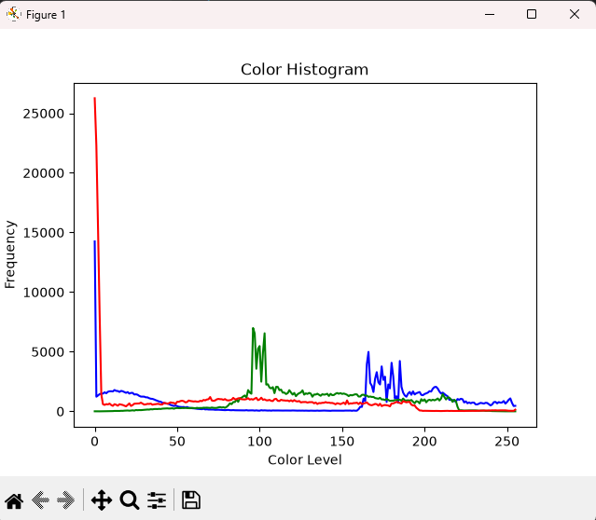

Result: Thus, the histogram of the given image was successfully analyzed based on its color levels using OpenCV.

